答案

- Mark each statement true or false ( 20 cents )
1. ( F) 2.（F）3.（T）4.（F）5.（F）
- （F）7.（F）8.（T）9. (F) 10. (F)
- Single Choice (15 cents)
1. A 2. A 3. D 4. A 5. A
6. C 7. C 8. C 9 A 10. A

- Questions ( 65 cents)
      - (5 cents)
[Solution]
A leftmost derivation is one in which the leftmost symbol is always be expanded.

2. (8 cents)
[Solution]
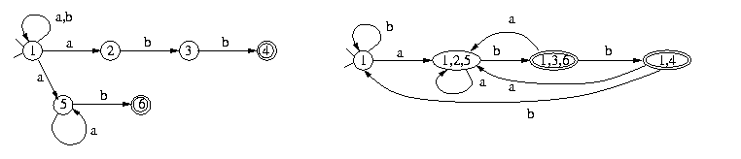
3. (6 cents)
[Solution]
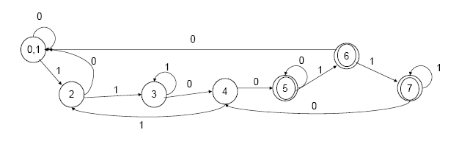
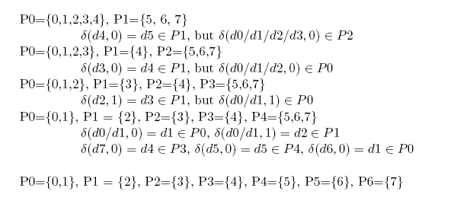
4. (12 cents)
[Solution]
 | nullable | FIRST | FOLLOW
S | no | a,+,( | )
A | no | a,+,( | *,)
B | yes | * | )

5. (15 cents)
[Solution]
We augment the grammar with a new start symbol S’ and a new production as below:
0 S’ →S$
1 S→aAd 2 S→bBd
3 S→aBe 4 S→bAe
5 A→c 6 B→c
The LR(1) states diagram as below:
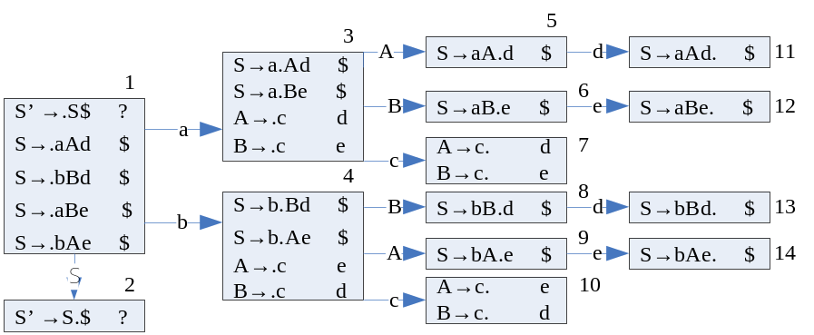

The LALR(1) states diagram as below:
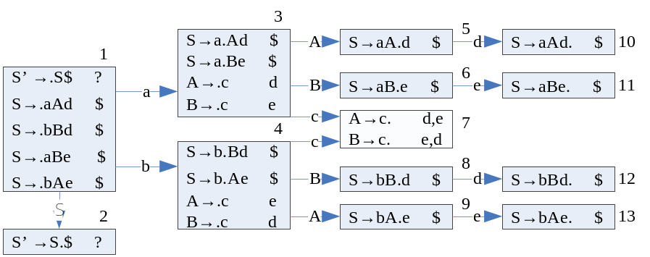

From the graphs, we know that LALR(1) table contains reduce-reduce conflicts, but the LR(1) table has none.

6. (11 cents)
(1) Show the symbol table when line 8 is compiled.
[Solution]
SHAPE \* MERGEFORMAT
0
1
2
3
4
5
6
7
8
9
a
string
a
int
b
int
c
int
j
int
c
int
(2) Show the symbol table when line 11 is compiled.
[Solution]
SHAPE \* MERGEFORMAT
0
1
2
3
4
5
6
7
8
9
a
int
b
int
c
int
7. (8 cents)

void main ( ) {
int x,y;
x= 0;
y = ABC (1,2,3);
………

}
int ABC (int a, int b, int c) {
double y;
char buffer[16];
int sum, x=1 ;
……….
return sum;
}

[Solution]

3
2
1
fp
静态链
y
y
sp
y
y
buffer[0] buffer[1]
buffer[2] buffer[3]
buffer[4] buffer[5]
buffer[6] buffer[7]
buffer[8] buffer[9]
buffer[10] buffer[11]
buffer[12] buffer[13]
buffer[14] buffer[15]
sum
x=1
return address ………
the temporary variables

